Day Planner app

Submitted: Sep 22,2023

Team members:

Vatsal

Divleen

Rohit

Abass

Rania   
Sumit

It’s a daily use tool designed for managing User’s daily tasks throughout the day.

With ease and efficiency. This approach is designed to minimize the complexity of the present task managing apps.

This app will save user data serverless and allow users to access the app through multiple devices. The app will be available for offline use as well and all the data will be synchronized automatically through the user’s google drive. The data will be retrieved by the drive and uploaded there too. This way the user can connect to the application using different devices.

Design Flow Diagram:

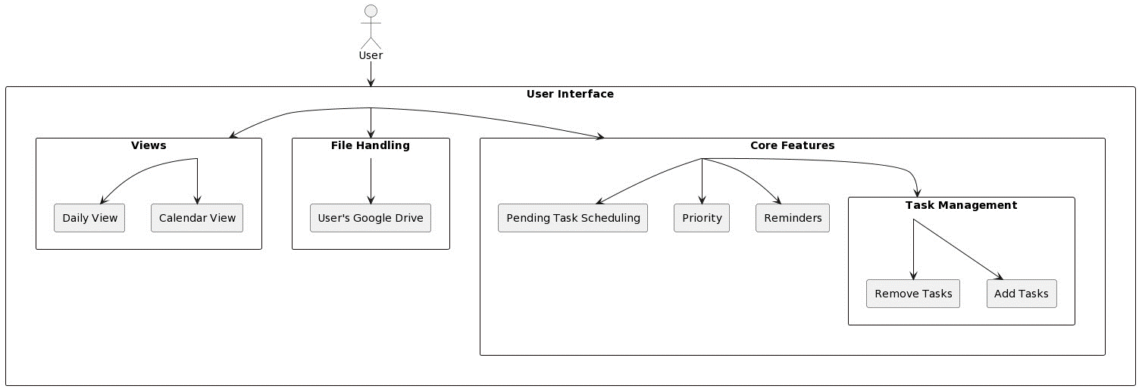

Use Case:

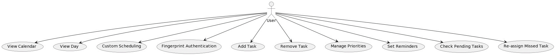

Flowchart :

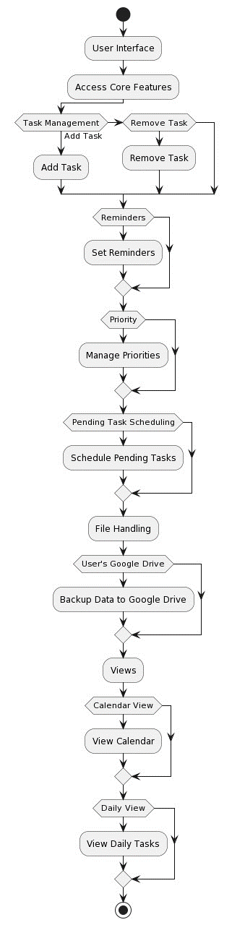

Demo – UI : <https://www.figma.com/file/muu5ZPYSEKCiawfRBJ1jle/Untitled?type=design&node-id=0%3A1&mode=design&t=v7KoOufiCNdKLKbv-1>

Tech- Spec:

* Platform: Flutter
* Language: Dart programming Language
* Google Drive: Data Management(storage).